

Use Case Specification: CSR eCL Survey
For
eCoaching Log

Change History Log

Date | Version | Description | Author
09/8/2015 | 1.0 | Initial Document | Doug Stearns

Table of Contents

1. Brief Description 6
2. Participating Actors 6
2.1 Primary 6
2.2 Secondary 6
3. Basic Flow of Events 7
3.1 Employee (CSR) reviews, acknowledges and completes an eCoaching Log from My Dashboard My Pending eCoaching Logs section. 7
3.2 System reviews completed logs during sampling period for the calendar month. 7
3.3 System generates eCoaching Survey eMail notification for selected employees. 7
3.4 Employee (CSR) receives system generated eMail notification of eCoaching Log Survey. The eMail notification will use the following: 7
3.5 Employee (CSR) selects hyper link in email to eCoaching Log Survey. 7
3.6 Employee (CSR) selects appropriate response to each question. 7
3.7 Employee (CSR) enters any desired comments (free form text up to 4000 characters). 7
3.8 Employee (CSR) submits the survey responses. 7
3.9 Status of eCoaching Log Survey becomes Completed. 7
4. Alternative Flows 8
4.1 Inactive. [Step 3.2] 8
4.2 No Completed Logs. [Step 3.2] 8
4.3 Already Surveyed. [Step 3.2] 8
4.4 Already Surveyed Exception. [Step 3.2] 8
4.5 Link to form. [Step 3.6] 8
4.6 Hot Topic. [Step 3.6] 8
4.7 Five Day Inactivation. [Step 3.5] 8
4.8 Individual Inactivation. [Step 3.5] 9
4.9 Employee Status. [Step 3.5] 9
4.10 Individual Deletions [Step 3.5] 9
5. Preconditions 9
5.1 eCoaching Log successfully completed. 9
5.2 System generated eMail notification sent to appropriate parties. 9
5.3 eCoaching Log Survey system available. 9
6. Postconditions 9
6.1 eCoaching Log Survey completed. 9
7. Assumptions and Dependencies 9
7.1 All reporting to be done outside of eCoaching Log and Survey systems. 9
7.2 Basic from of eMail notification is as follows: 9
8. Business Rules 10
8.1 none 10
9. Technical Requirements 10
9.1 none 10
10. Activity Diagrams 11

Table of Figures
Figure 1 – CSR eCL Survey 12

Brief Description
eCoaching Log notifications and acknowledgment for CSR Survey.

Participating Actors

Primary

CSR

Secondary

Supervisors

Managers

Basic Flow of Events

Employee (CSR) reviews, acknowledges and completes an eCoaching Log from My Dashboard My Pending eCoaching Logs section.

System reviews completed logs during sampling period for the calendar month.

System generates eCoaching Survey eMail notification for selected employees.

Employee (CSR) receives system generated eMail notification of eCoaching Log Survey. The eMail notification will use the following:

Subject:
eCoaching Log Survey
Message:
Please take the time to complete this survey regarding a coaching session for [FormID]. This survey will expire <ExpirationDate>.

Employee (CSR) selects hyper link in email to eCoaching Log Survey.

Employee (CSR) selects appropriate response to each question.

Employee (CSR) enters any desired comments (free form text up to 4000 characters).

Employee (CSR) submits the survey responses.

Status of eCoaching Log Survey becomes Completed.

Alternative Flows

Inactive. [Step 3.2]

Employee is Inactive at time of survey selection.

Employee is not eligible for eCoaching Log Survey.

No Completed Logs. [Step 3.2]

Employee has not acknowledged and completed any non-Verint-TQC logs during sampling period.

Employee is not eligible for eCoaching Log Survey.

Already Surveyed. [Step 3.2]

Employee has already received eCoaching Log Survey during the calendar month.

Employee is not eligible for another eCoaching Log Survey.

Already Surveyed Exception. [Step 3.2]

Employee had already received eCoaching Log Survey during the calendar month and has expired without being completed.

Program desires a larger number of survey responses.

Employee becomes eligible for another eCoaching Log Survey during calendar month.

Continue with step 3.3 above.

Link to form. [Step 3.6]

Employee (CSR) selects the hyperlink to corresponding completed log.

System displays completed review page of log.

Employee (CSR) closes log.

Continue with step 3.6 above.

Hot Topic. [Step 3.6]

Program had decided on additional Hot Topic survey question for month.

Employee (CSR) selects appropriate response to Hot Topic question.

Employee (CSR) enters any desired comments to Hot Topic question (free form text up to 4000 characters).

Continue with step 3.6 above.

Five Day Inactivation. [Step 3.5]

Employee (CSR) fails to complete survey questions within 5 days of creation.

eCoaching Log Survey becomes inactive and is no longer able to be responded to.

Individual Inactivation. [Step 3.5]

The eCoaching Log is inactivated.

The corresponding eCoaching Log Survey is inactivated.

Employee Status. [Step 3.5]

Employee active status is a T or D from PeopleSoft and employee is inactivated.

Uncompleted surveys for employee will be inactivated.

Individual Deletions [Step 3.5]

The eCoaching Log is deleted.

The corresponding eCoaching Log Survey is deleted.

Preconditions

eCoaching Log successfully completed.

System generated eMail notification sent to appropriate parties.

eCoaching Log Survey system available.

Postconditions

eCoaching Log Survey completed.

Assumptions and Dependencies

All reporting to be done outside of eCoaching Log and Survey systems.

Basic from of eMail notification is as follows:

To – [to]
Subject – eCoaching Log Survey
** This is an automated email. Do not reply to this email. **
Please take time to complete this survey regarding a coaching session for [FormID]. This survey will expire on [ExpirationDate].
Please click here to open the survey form and respond to the questions. [Link to Survey Form]
(Please do not respond to this automated notification)
Thank you,
eCoaching Log Team


Business Rules

none

Technical Requirements

none

Activity Diagrams
Below is the activity diagram for the use case that provides a visual depiction of the flow of events.

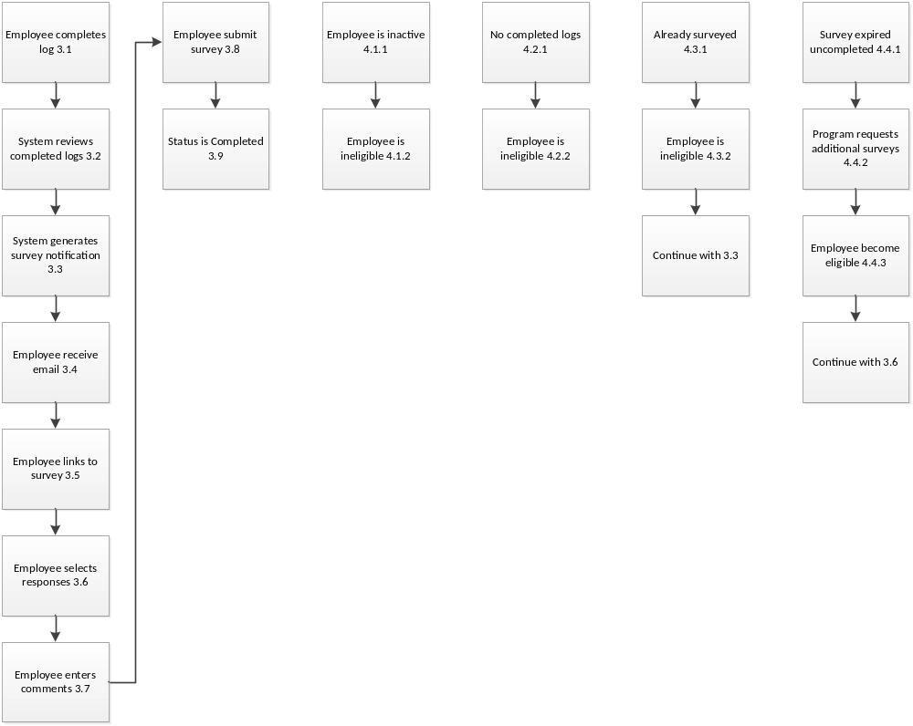

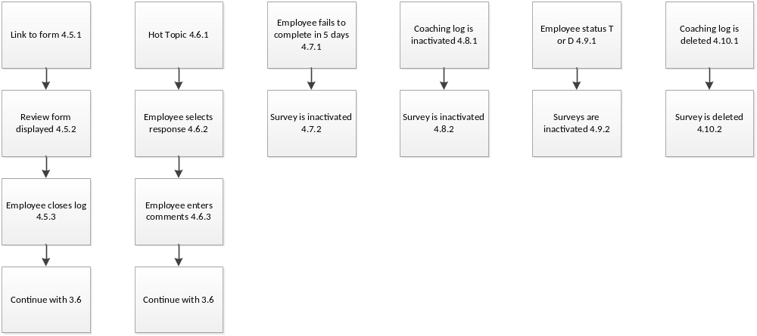

Figure 1 – CSR eCL Survey

